Project Design Phase-II
Data Flow Diagram & User Stories

Team ID | SWTID1745140705
Project Name | Shopez: E-Commerce Application
Maximum Marks | 4 Marks

Data Flow Diagram:
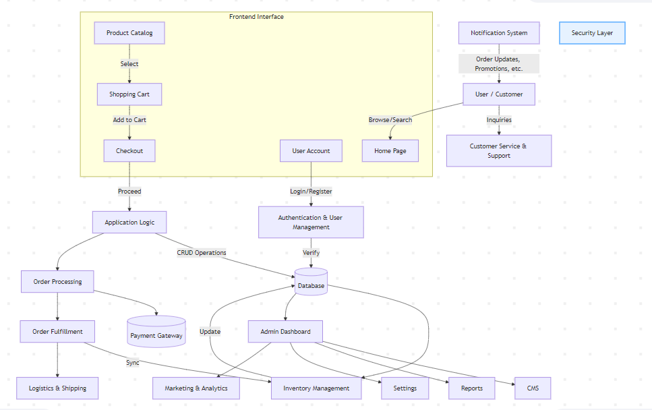
User Stories:
User Type | Functional Requirement (Epic) | User Story Number | User Story / Task | Acceptance criteria | Priority | Release
Customer (Mobile user) | Registration | USN-1 | As a user, I can register for the application by entering my email, password, and confirming my password. | I can access my account / dashboard | High | Sprint-1
 |  | USN-2 | As a user, I will receive confirmation email once I have registered for the application | I can receive confirmation email & click confirm | High | Sprint-1
 |  | USN-3 | As a user, I can register for the application through Facebook | I can register & access the dashboard with Facebook Login | Low | Sprint-2
 |  | USN-4 | As a user, I can register for the application through Gmail |  | Medium | Sprint-1
  I can register & access
  the dashboard with Gmail
  Login
 | Login | USN-5 | As a user, I can log into the application by entering email & password | I can access my dashboard after login | High | Sprint-1
 | Dashboard | USN-6 | As a user, I can view my account information and recent activity | Dashboard loads with latest activity and user profile | High | Sprint-2
Customer (Web user) | Registration/Login | USN-7 | As a web user, I can register/login using email or social login | I can login or register successfully | High
  Sprint-2
 | Search Products | USN-8 | As a web user, I can search for products |  | High | Sprint-2
  Search results are
  accurate and displayed
  promptly
 |  | USN-9 | As a web user, I can place an order by adding products to the cart and making payment | Order placed successfully and confirmation received | High
  Order Placement
  Sprint-3
Customer Care Executive | View Complaints | USN-10 | As a CCE, I can view complaints raised by users | Complaints load correctly with details | Medium | Sprint-3
 | Respond to Complaints | USN-11 | As a CCE, I can respond to complaints with proper resolution steps | User receives response notification
  Medium
  Sprint-3
Administrator | Manage Users | USN-12 | As an admin, I can view, edit, and delete user accounts | Admin actions reflect on user system | High | Sprint-2
 |  | USN-13 | As an admin, I can add/edit/remove product listings | Product catalog updates correctly | High | Sprint-3
  Manage Products
 | View Reports |  | As an admin, I can view analytics and reports for system activity | Reports generate accurately and quickly | Medium
  USN-14
  Sprint-3

